# Quinte Financial Technologies | FinTech Solutions

**Assignment on**

**FEDERAL DEPOSIT INSURANCE CORPORATION,**

**OFFICE OF THE COMPTROLLER OF THE CURRENCY AND**

**THE FEDERAL RESERVE SYSTEM**

**Under Supervision of:**

**Mr. Mohammad Mozammil**

**Submitted On:**

**11th June, 2024**

**Submitted By:**

**Archita Gupta**

Table of Contents

Federal Deposit Insurance Corporation (FDIC) 2

Brief History: 4

Office of the Comptroller of the Currency (OCC) 6

The Federal Reserve System 10

# 

# Federal Deposit Insurance Corporation (FDIC)



The Federal Deposit Insurance Corporation (FDIC) is an independent federal agency established in 1933 during the Great Depression to restore trust in the American banking system. It provides deposit insurance to protect depositors, in American commercial banks and savings banks, in case of bank failures and oversees the safety and soundness of financial institutions.

As of 2023, the FDIC insures deposits up to $250,000 per depositor as long as the institution is a member firm. It is critical for consumers to confirm whether their institution is FDIC-insured.

As of March 2024, the FDIC provided deposit insurance at 4,568 institutions. As of Q1 2024, the Deposit Insurance Fund stood at $125.3 billion.

The FDIC **does not** insure:

* Stock Investments
* Bond Investments
* Mutual Funds
* Crypto Assets
* Life Insurance Policies
* Annuities
* Municipal Securities
* Safe Deposit Boxes or their contents
* U.S. Treasury Bills, Bonds, or Notes

**Key Functions and Responsibilities**:

1. **Deposit Insurance**: Insures deposits in member banks to protect depositors in case of bank failures.
2. **Bank Supervision**: Conducts regular examinations and evaluations of member banks to ensure compliance with regulatory requirements and to promote sound banking practices. In 2021, the FDIC conducted over 1,500 risk management and consumer compliance examinations.
3. **Resolution of Failed Banks**: Manages the receivership process for failed banks, ensuring depositors have quick access to their insured funds and that the assets of the failed banks are liquidated efficiently.
4. **Consumer Protection**: Enforces consumer protection laws and regulations to ensure fair and transparent banking practices. Provides educational resources and tools to help consumers make informed financial decisions. For example, the FDIC's Money Smart program offers free financial education materials to consumers of all ages.
5. **Risk Management and Financial Stability**: Identifies and monitors potential risks to the banking system, working proactively to address emerging threats. The FDIC maintains the Deposit Insurance Fund (DIF) to cover insured deposits in case of bank failures. As of December 2021, the DIF balance was approximately $123.1 billion.

## Brief History:

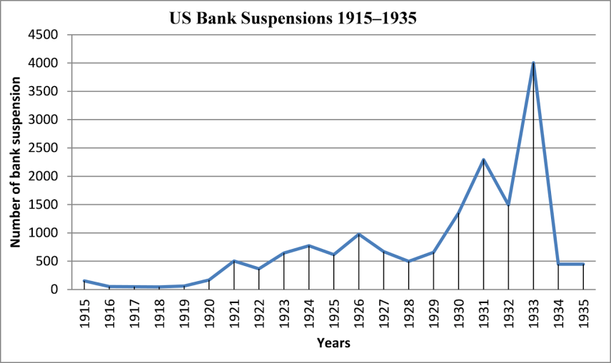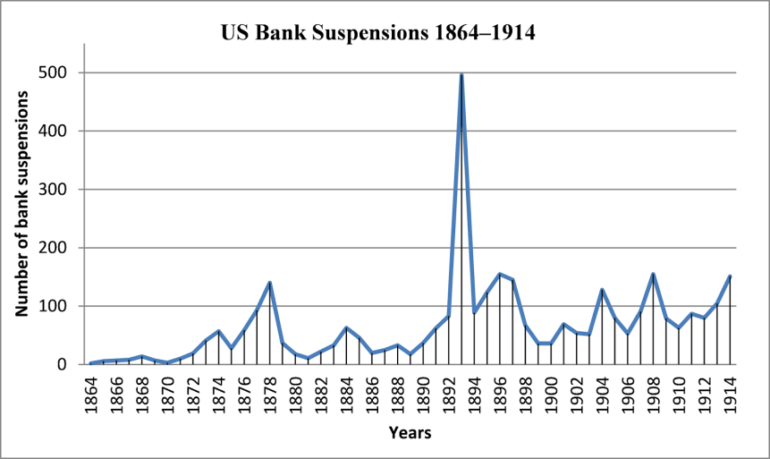

US Bank Suspensions 1864-1914:

* Highest peak was around 1893 with over 500 bank suspensions
* Other notable peaks around 1878 (around 350 suspensions), 1887 (around 250 suspensions), and 1908 (around 200 suspensions)

US Bank Suspensions 1915-1935:

* First peak was in 1921 with around 500 suspensions
* Major peak was in 1933 with over 4,000 suspensions, during the Great Depression
* Smaller peaks in 1924 (around 800 suspensions) and 1927 (around 600 suspensions)
* In most years between 1915-1935, there were under 200 bank suspensions annually

Before deposit insurance, depositors risked losing money if their bank failed due to loan losses or sudden withdrawals, often triggering wider panics. The Panics of 1893 and 1907 highlighted the need for deposit insurance.

Bank instability was severe before the Great Depression, with 5,700 failures from 1921 to 1929 and nearly 10,000 from 1929 to 1933. A panic in February 1933 led most states to close all banks.

On June 16, 1933, President Franklin D. Roosevelt signed the 1933 Banking Act into law, creating the FDIC. The initial plan set by Congress in 1934 was to insure deposits up to $2,500 ($56,940 today) and adoption of a more generous, long-term plan after six months.

The graph shows the real value of deposit insurance coverage in the United States over time from 1934 to 2018, adjusted for inflation (in 2008 dollars) and nominal values. The real value of deposit insurance fluctuated significantly, peaking around $225,000 in the late 1970s/early 1980s before declining in recent years.[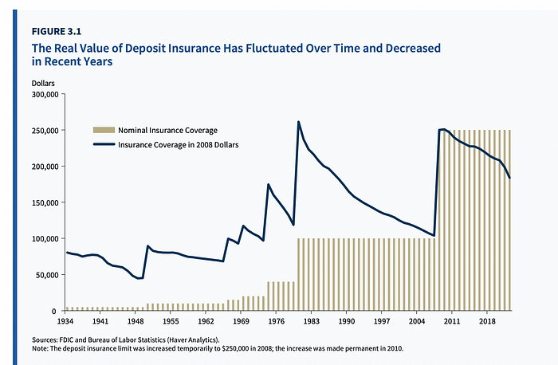](https://www.fdic.gov/analysis/options-deposit-insurance-reforms/report/options-deposit-insurance-reform-section-3.pdf) FDIC insures deposits up to $250,000 per depositor as of 2023.

# Office of the Comptroller of the Currency (OCC)

The Office of the Comptroller of the Currency (OCC) is an independent bureau within the United States Department of the Treasury that was established by the National Currency Act of 1863 that regulates and supervises national banks and federal savings associations. It ensures the safety and soundness of these financial institutions, enforces banking laws, and promotes fair and equal access to financial services.

Headquartered in Washington, D.C., it has four district offices located in New York City, Chicago, Dallas and Denver. It has an additional 92 operating locations throughout the United States.

The acting Comptroller of the Currency is Michael J. Hsu, who took office on May 10, 2021.

The OCC currently supervises 1055 national banks, federal savings associations, and federal branches and associations of foreign banks and has 2349 OCC examiners located across 70 operating locations.

The OCC's operating and capital budget ($1.289B for FY2024) is funded primarily by assessments, fees paid by banks, interest received on investments, and other income.

Value of Bank Assets ($15.6T) held by OCC-regulated institutions compose 66 percent of all U.S. commercial banking assets.

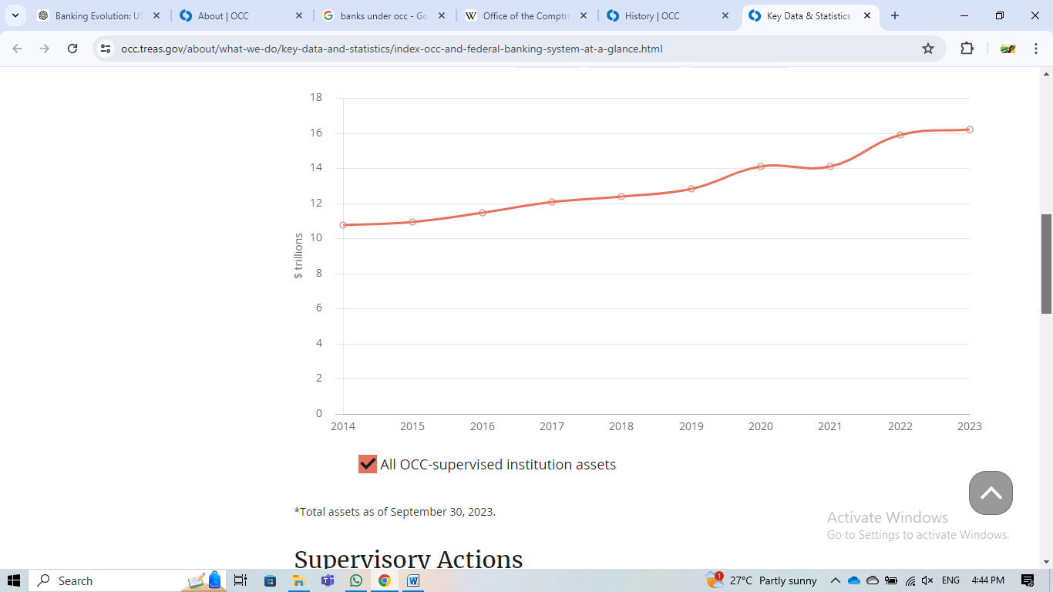**All OCC-supervised institutions, total assets (in $ trillions):**

**Key Functions and Responsibilities**:

1. **Chartering National Banks**: Issues charters for new national banks and federal savings associations, allowing them to operate legally in the United States.

As of Year 2023, OCC supervises 765 national banks, 248 federal savings associations, 49 federal branches and agencies.

1. **Regulating and Supervising**:
   * **Supervision**: Conducts regular examinations and evaluations to ensure national banks and federal savings associations adhere to sound banking practices and comply with applicable laws and regulations. In 2021, the OCC conducted over 1,700 examinations of national banks and federal savings associations.
   * **Guidance**: Provides guidance on risk management, capital adequacy, and operational practices.
2. **Enforcing Compliance**:
   * **Compliance**: Enforces banking laws and regulations, including anti-money laundering (AML) laws, the Bank Secrecy Act (BSA), and consumer protection laws.
   * **Penalties**: Imposes penalties and takes corrective actions against institutions that violate laws or engage in unsafe practices.

In 2023, the OCC issued 43 enforcement actions of $107,052,500.

1. **Ensuring Fair Access**:
   * **Fair Lending**: Promotes fair access to financial services and enforces laws that prohibit discriminatory lending practices.
   * **Community Reinvestment**: Ensures that banks meet the credit needs of their communities, particularly low- and moderate-income neighborhoods, through the Community Reinvestment Act (CRA).

In 2021, the OCC rated 90% of national banks and federal savings associations as satisfactory or outstanding under CRA evaluations.

1. **Monitoring Financial Health**:
   * **Risk Assessment**: Identifies and monitors risks to the banking system, including credit risk, market risk, and operational risk.
   * **Stress Testing**: Conducts stress tests to assess the resilience of banks under adverse economic conditions.
   * **Data**: In 2021, the OCC's stress tests covered banks holding over $10 trillion in combined assets.
2. **Providing Expert Guidance**:
   * **Advisory**: Offers expert guidance and technical assistance to national banks and federal savings associations on regulatory compliance, risk management, and best practices.
   * **Data**: The OCC issued over 40 new or revised supervisory policies and guidance documents in 2021.
3. **Facilitating Innovation**:
   * **Fintech and Innovation**: Supports responsible innovation in the financial sector, including the adoption of new technologies and business models, while ensuring risks are managed appropriately.

The OCC’s Office of Innovation engaged with over 200 fintech companies and banks in 2021 to discuss regulatory expectations and promote innovation.

1. **Maintaining Public Trust**:
   * **Transparency and Accountability**: Ensures transparency in its operations and decision-making processes to maintain public trust in the national banking system.

The OCC held 12 public meetings and forums in 2021 to discuss regulatory changes and gather stakeholder feedback.

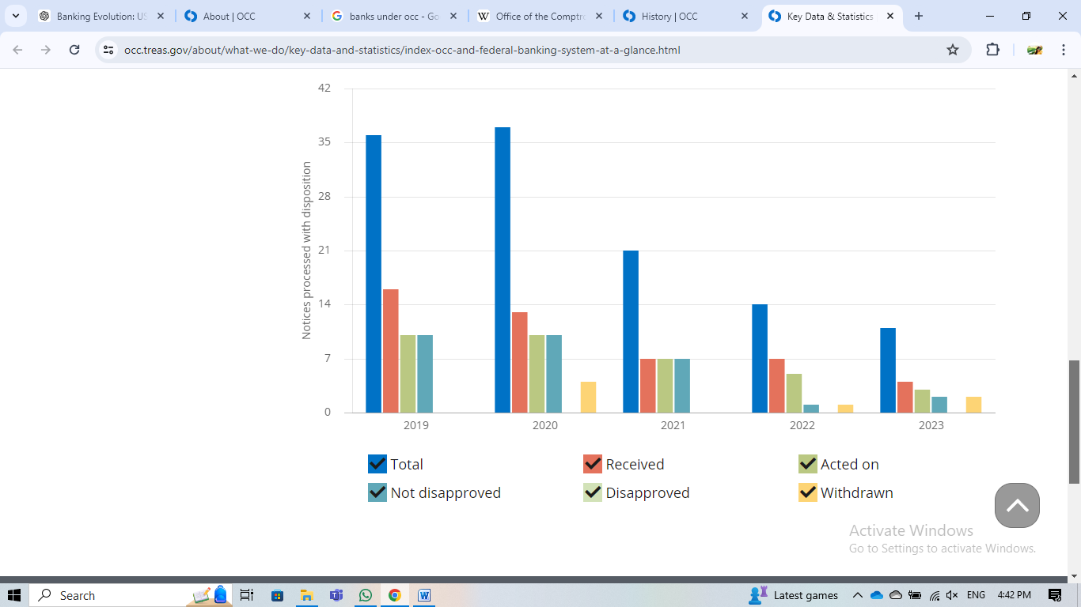**Change in Bank Control Act (Notices Processed With Disposition):**

The Change in Bank Control Act of 1978 is a U.S. federal law designed to ensure that acquisitions of control of banks and bank holding companies occur in a manner consistent with the soundness and stability of the banking system. The Act requires individuals or entities intending to acquire control of a bank to notify the appropriate federal banking agency, which in the case of national banks and federal savings associations, is the Office of the Comptroller of the Currency (OCC).

### 

# The Federal Reserve System

The **Federal Reserve System**, established by the Federal Reserve Act of 1913, is the central bank of the United States. Created to address financial instability, the Fed consists of a Board of Governors in Washington, D.C., and twelve regional Federal Reserve Banks. It manages the nation's money supply and interest rates, supervises banks, maintains financial stability, and provides financial services to institutions and the government. The Fed conducts monetary policy through open market operations, setting the discount rate, and regulating reserve requirements, aiming to promote maximum employment, stable prices, and moderate long-term interest rates.

The Fed is a complex system with several key entities working together:

* **Board of Governors:** Appointed by the President and confirmed by the Senate, these seven individuals oversee the entire Federal Reserve System. They set monetary policy by determining the federal funds rate, which influences other interest rates in the economy.
* **Federal Reserve Banks:** There are twelve regional Federal Reserve Banks located throughout the US. They:
  + Hold reserves for member banks.
  + Provide financial services to banks, including lending and check clearing.
  + Implement monetary policy directives set by the Board of Governors.
* **Federal Open Market Committee (FOMC):** This committee, made up of the Board of Governors and five representatives from the Federal Reserve Banks, sets the target federal funds rate through open market operations.

**Key Functions and Responsibilities**:

1. **Monetary Policy**:
   * **Objective**: Manages the nation’s money supply and interest rates to achieve maximum employment, stable prices, and moderate long-term interest rates.
   * **Tools**: Utilizes tools such as open market operations, the discount rate, and reserve requirements.
   * As of June 2023, the federal funds rate target range is 5.00% to 5.25%.
2. **Financial Supervision and Regulation**:
   * **Supervision**: Supervises and regulates banking institutions to ensure the safety and soundness of the nation’s banking and financial system.
   * **Consumer Protection**: Enforces consumer protection laws and promotes fair lending practices.
   * The Fed oversees approximately 5,000 bank holding companies, 850 state-chartered banks, and numerous other financial institutions as of 2022.
3. **Financial Stability**:
   * **Monitoring**: Monitors and addresses risks to the financial system to enhance stability and prevent financial crises.
   * **Crisis Management**: Provides liquidity to banks during times of financial stress through its lender of last resort function.
   * During the 2020 COVID-19 pandemic, the Fed launched emergency lending programs totaling over $2 trillion to support the economy.
4. **Payment Systems**:
   * **Facilitation**: Ensures the efficiency and safety of the payments and settlement system, including electronic payments and check clearing.
   * **Innovation**: Supports and implements innovations in payment technologies.
   * The Fed processes approximately 6 billion checks annually, with a total value exceeding $30 trillion.
5. **Economic Research and Data**:
   * **Research**: Conducts research on economic issues and provides data and analysis to policymakers, academics, and the public.
   * **Publications**: Publishes reports such as the Beige Book, which provides a summary of economic conditions across the country.
   * The Fed’s research division produces hundreds of working papers, research articles, and policy reports each year.
6. **Services to the U.S. Government**:
   * **Fiscal Agent**: Acts as a fiscal agent for the U.S. government, managing the Treasury's payments, selling government securities, and handling currency issuance.
   * **Advisory**: Provides financial and economic advice to the federal government.
   * The Fed manages the issuance of over $2 trillion in Treasury securities annually.

Thank You